

Table of Contents

About 2

Getting Started 2

What’s included? 2

Known MOD issues 2

PCSX2 Requirements 3

Additional Uniforms 4

Preparing NFL2K5 Resurrected 6

Plugin/BIOS Settings 6

Video (GS) Settings 7

Widescreen Settings 10

Audio (SPU2) Settings 11

Memory cards 12

Controller setup 13

Configuring the 40GB VHDD (Halftime show) 14

Configure the Plug-in 14

Formatting the VHDD 15

Pre-loaded memory cards 17

Credits 17

# About

This project started in March with the help of PCSX2 developer TopazTK for his GSDx plug-in project. Everyone involved in this project knows the amount of time and energy that has gone into this. We should all be proud of what we have accomplished because for the first time in the history of NFL 2K5. The community now has a way to enjoy and play NFL 2K5 with updated textures. This document will help everyone setup the highly anticipated ***NFL 2K5 Resurrected mod***.

**SOCIALS**

* [Discord](https://discord.gg/sBVXzYb) - best place for help with various questions and the latest news
* [YouTube](https://www.youtube.com/lostsoul63b) - best place for video updates
* [Twitter](https://twitter.com/blostsou)

# Getting Started

This build release is based on stable PCSX2 1.6 and includes all mod files plus the working plug-in needed to run this mod. The initial release includes an overhaul of menus, logos, stadiums, uniforms, even Chris Berman and the sports desk.

***Note: You will need to use your own PS2 BIOS as well as your own NFL 2K5 PS2 ISO***

## What’s included?

* Updated textures
* Pre-loaded memory cards
* Custom video graphics shaders (by RateSports)
* Custom settings, playbook and vip files (by RateSports)
* 2K21 Ros + Fran files
* uLE v4.38 boot DVD ISO

## Known MOD issues

* **Duplicate Uniform textures**:
  + Current away jersey (BUF), same as 1967 white jersey (ATL)
  + Current away sleeves share texture across LAC, NYG, IND, HOU

If you find additional issues, please report them in our [Discord](https://user-images.githubusercontent.com/69597675/124640725-d1e88980-de5b-11eb-926d-ec5f55b19a62.png) [Discord](https://discord.gg/sBVXzYb)

## PCSX2 Requirements

Additional Uniforms

See below to know which teams have additional uniforms.

|  |  |
| --- | --- |
|  | - Current  - 93-94  - 64-93 |
|  | - Current |
|  | - Current  - 02 Alt |
|  | - Current |
|  | - Current  - 85-96 |
|  | - Current |
|  | - Current |
|  | - Current  - 93-94 |
|  | - Current  - 85-87  - 83-84 |
|  | - Current |
|  | - Current |
|  | - Current  - 94 Alt |
|  | - Current |
|  | - Current |

|  |  |
| --- | --- |
|  | - Current |
|  | - Current  - 81-99 |
|  | - Current |
|  | - Current  - 90-93 |
|  | - Current |
|  | - Current  - 03 Alt 1 |
|  | - Current  - 96  - 03 Alt |
|  | - Current |
|  | - Current |
|  | - Current  - 98-99 |
|  | - Current |
|  | - Current |
|  | - Current |
|  | - Current  - 83-02 |
|  | - Current |
|  | - Current |
|  | - Current |
|  | - Current  - 93-94 |

# Preparing NFL2K5 Resurrected

Extract the **PCSX2_NFL2KR** folder from the zip you downloaded to anywhere you want the folder to reside locally. Then copy your PS2 BIOS into the bios directory *(.\PCSX2_NFL2KR\bios)* then follow the steps below.

***Note: You will need to add your own PS2 BIOS***

## Plugin/BIOS Settings

|  |  |
| --- | --- |
| From the Config drop down > select Plugin/BIOS Selector |  |
| **\*\* You will select your bios\*\*** |  |
| Select Plugins (top left) and confirm the folder location matches where you extracted to matches |  |

## Video (GS) Settings

|  |  |
| --- | --- |
| From the Config menu > select Video (GS) > Plugin Settings… |  |
| Update the adapter value to that of your video card.  All other settings will be set as shown by default in the base 1.6 emulator build.  The GSDx plug-in will be pre-configured  ***\*DO NOT CHANGE THESE SETTINGS\**** |  |
| Select Advanced Settings and Hacks |  |
| These settings will be set as shown by default in the base 1.6 emulator build. |  |
| Select Shader Configuration under Software Renderer Settings |  |
| **External Shader Settings**   * Press **Browse** * Expand **PC Version >> PCSX2 1.6.0 – 2K5 >> Shaders** * Select **GSdx.fx**   **External Shader Config Settings**   * Press Browse * Expand **PC Version >> PCSX2 1.6.0 –** **2K5 >> Shaders** * **Select NFL 2K17.ini** |  |

## Widescreen Settings

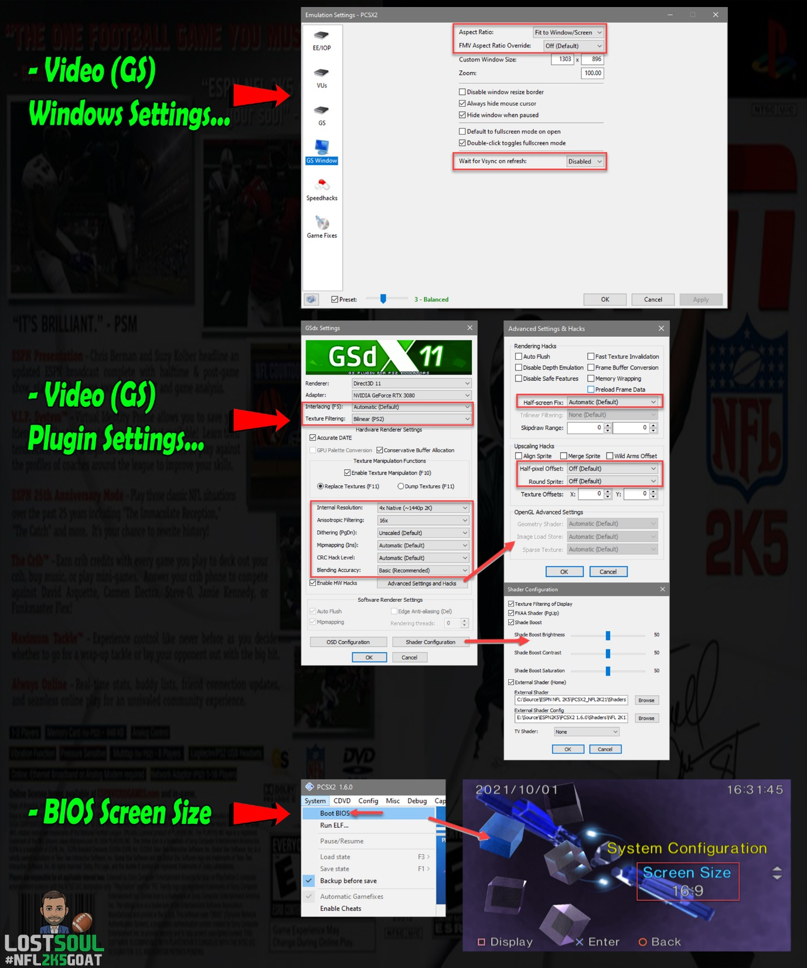

## Audio (SPU2) Settings

|  |  |
| --- | --- |
| From the Config menu > select Audio (SPU2) > Plugin Settings… |  |
| Click Configure… > confirm that the device is set to default or you can set this to whatever you use for your audio |  |

## Memory cards

Make sure the included pre-loaded memory cards are inserted into both slots in the emulator.

|  |  |
| --- | --- |
| From the Config menu > select Memory cards |  |
| Confirm both slots have the included memory cards loaded. If not, then select the memcard in the list and click insert to assign the memcard to the slot you want. |  |

## Controller setup

I recommend everyone go into the ***Controllers (PAD) >* Plugin Settings** and manually map their controller. If you will be using two controllers, then you will want to map Pad 1 (controller 1) and Pad 2 (controller 2), to ensure they are recognized in-game.

|  |  |
| --- | --- |
| Under the Config menu > select Controllers (PAD) > Plugin Settings… |  |
| Select the Pad 1 tab and then map all of your connected controller buttons. When done click Apply + Ok to close the plugin settings.  If you will be playing 2 players locally. I recommend you also map Pad 2 when the second controller is connected, to ensure it’s recognized in-game. |  |

# Configuring the 40GB VHDD (Halftime show)

The following steps will provide everything that is needed to configure the 40GB vhdd needed to support the Chris Berman Halftime show video replay.

## Configure the Plug-in

|  |  |
| --- | --- |
| From the Config menu > select Dev9 > Plugin Settings… |  |
| Check Enable Hdd > click Options > browse to the location the vhdd will reside and ensure the size is 40GB then click Apply  **\*\*Make sure you select the correct file path where you want the disk created\*\***  Allow the vhdd to be built before continuing |  |

## Formatting the VHDD

The following steps will walk you through formatting the new vhdd.

|  |  |
| --- | --- |
| From the CDVD menu > select ISO Selector and confirm the uLE v4.38 boot DVD ISO.iso is selected then boot the system (fast)  Extract the uLE v4.38 boot DVD ISO found in **PC Version >> iso**  Browse to **PC Version >> iso >> uLE v4.38 boot DVD ISO** >> **set the iso** |  |
| Make sure to select **Boot ISO (fast)** when launching the uLE boot iso |  |
| Select FileBrowser |  |
| Select MISC/ |  |
| Select HddManager |  |
| Hit R1 to open the options |  |
| Select Format > OK |  |
| Exit |  |

# Pre-loaded memory cards

Included are two pre-loaded memory cards.

The memory card in slot 1 includes.

* CujoMatty’s Week 1 Hi Overall Ros + Fran + Playbook + Settings + VIP *(NFL22)*

The memory card in slot 2 includes.

* CujoMatty’s Week 1 Low Overall Ros + Fran + Playbook + Settings + VIP *(NFL22)*

# Credits

The NFL2K5 Resurrected Mod is a collaborative effort by the NFL2K5 Mod Community.

Many thanks to the team:

* LostsouL
* xflamexofxhopex
* Xevan
* Orleans02
* BAD_AL
* CujoMatty
* UXG
* MSweeets
* BTZero
* drhotwing
* SteelPro43
* CCGames
* Rick
* Heavvy
* MahomesMagic15